AMITY UNIVERSITY UTTAR PRADESH
Amity School of Engineering and Technology
Department of Information Technology

PROJECT REPORT

TaskFlow
Full-Stack Task Management Web Application

INTEGRATED PROJECT | Semester 6
B.Tech Information Technology (2023-27)

Submitted To
Department of Information Technology
Amity School of Engineering and Technology
Amity University Uttar Pradesh

Project Information
Project Title | TaskFlow - Full-Stack Task Management Web Application
Project Type | Integrated Project
Semester | Semester 6
Program | B.Tech Information Technology (2023-27)
Institution | Amity School of Engineering and Technology, Amity University UP
Department | Department of Information Technology
Technology Stack | Python, FastAPI, SQLAlchemy, SQLite, HTML5, CSS3, Vanilla JavaScript
Deployment | Vercel (Live) - task-management-applicationtaskflow.vercel.app
Delivery | Browser-based Full-Stack Web Application with JWT Authentication

Abstract
Effective task management is a critical requirement for individuals, development teams, and academic groups seeking to organise their work, meet deadlines, and track progress across multiple responsibilities. Despite the availability of complex project management tools, many users require a lightweight, accessible, and intuitive solution that provides full task lifecycle management without the overhead of enterprise software.
This project, TaskFlow, is a full-stack task management web application developed using Python FastAPI for the backend and vanilla HTML5, CSS3, and JavaScript for the frontend. The system enables users to register and authenticate securely, create and organise tasks with priority levels, status tracking, custom tags, and due dates, and manage their workflow through both a Kanban board view and a sortable list view. Drag-and-drop functionality on the Kanban board allows intuitive task status transitions between To Do, In Progress, and Completed columns.
The application is built on a RESTful API architecture with JWT-based token authentication, SQLAlchemy ORM for database interactions, and SQLite for persistent storage. The frontend dashboard presents real-time statistics including total tasks, completion rate, in-progress count, and urgent task alerts, alongside full CRUD operations accessible through a modal interface. TaskFlow is deployed live on Vercel and accessible to any user with a browser, with no installation required.

Objectives
The primary objective of this project is to develop a complete, production-ready task management web application that demonstrates full-stack development competency. The specific objectives are:
- To implement a secure user authentication system using JWT tokens and SHA-256 password hashing, enabling multi-user account isolation with register and login functionality.
- To design and build a RESTful FastAPI backend with complete CRUD endpoints for task management, supporting filtering by status, priority, and tag with per-user data scoping.
- To develop a SQLAlchemy ORM data model with User and Task entities, supporting full task metadata including title, description, priority level, status, tag, due date, and completion state.
- To build an interactive Kanban board with three columns (To Do, In Progress, Completed) and HTML5 drag-and-drop functionality allowing users to transition tasks between columns.
- To implement a list view alternative that presents all tasks in a sortable tabular format with inline action buttons for editing, completing, and deleting tasks.
- To develop a real-time statistics dashboard displaying total tasks, completed tasks, in-progress tasks, urgent tasks, and overall completion rate.
- To implement task filtering by status, priority, and tag via sidebar navigation and top-bar filter controls, with a live search function for instant task lookup.
- To design a professional dark-themed responsive UI with animated components, toast notifications, keyboard shortcuts, and modal-based task creation and editing.
- To deploy the application live on Vercel, making it accessible to any user via a public URL with no installation or local setup required.

Introduction
Task management is one of the most fundamental requirements in both personal productivity and collaborative software development. Whether managing coursework deadlines, tracking development tickets, or coordinating team deliverables, individuals and groups require a system that provides visibility into what needs to be done, what is in progress, and what has been completed.
Existing task management tools such as Jira, Trello, and Asana address enterprise-scale needs but introduce significant complexity, configuration overhead, and cost barriers that make them unsuitable for individual users or small academic teams. TaskFlow addresses this gap by delivering a complete task management platform built on a modern full-stack architecture.
The backend is built on Python FastAPI, selected for its high performance, automatic API documentation generation, and native support for asynchronous request handling. The database layer uses SQLAlchemy ORM with SQLite, providing a zero-configuration persistent data store. Authentication is implemented using a custom JWT token system built on the Python standard library without external dependencies.
The frontend is implemented in vanilla HTML5, CSS3, and JavaScript without any frontend framework, demonstrating that a professional, animated, and fully interactive user interface can be delivered without React, Vue, or Angular. This architectural decision minimises load time, maximises browser compatibility, and keeps the codebase readable and maintainable.

Methodology
The development of TaskFlow follows a structured, phased approach integrating backend API development, database design, authentication implementation, and frontend interface construction.
Phase 1: Requirements Analysis and System Design
The initial phase defined the complete feature set, data model, and API contract. Core requirements were established as: multi-user authentication, full task CRUD, Kanban and list views, filtering and search, real-time statistics, and drag-and-drop status transitions.
Phase 2: Backend API Development
The FastAPI backend was implemented across five modules: main.py for application initialisation, database.py for SQLAlchemy session management, models.py for ORM entity definitions, auth.py for JWT token management, and two route modules for user and task endpoints.
Phase 3: Database Design
The SQLAlchemy ORM models define User and Task tables with appropriate constraints and relationships. Database creation is handled automatically via Base.metadata.create_all() on startup, requiring no manual schema management.
Phase 4: Authentication System
Authentication uses a custom JWT system built on Python standard library: hashlib for SHA-256 password hashing with random salt, hmac for token signing, and base64 for URL-safe encoding. Tokens carry a 7-day expiry and are verified on every protected API request.
Phase 5: Frontend Development
The frontend consists of two HTML pages: login.html for authentication and dashboard.html for the main application. All API communication uses the Fetch API with async/await, with the JWT token stored in localStorage and attached as a Bearer header on every request.
Phase 6: Deployment
The application is deployed on Vercel using a custom vercel.json configuration routing all requests through a FastAPI serverless function. The deployment pipeline is integrated with GitHub, enabling automatic redeployment on every push to the main branch.

System Design
Technology Stack
Component | Technology
Backend Framework | Python FastAPI 0.111
Database ORM | SQLAlchemy 2.0 - SQLite
Authentication | Custom JWT (hashlib SHA-256, hmac, base64)
Data Validation | Pydantic v2
Server | Uvicorn ASGI Server
Frontend | HTML5 + CSS3 + Vanilla JavaScript (ES6+)
Cross-Origin | FastAPI CORS Middleware
Deployment | Vercel Serverless (Python Runtime)
Version Control | Git + GitHub

API Endpoints
Method | Endpoint | Description
POST | /api/auth/register | Register new user account
POST | /api/auth/login | Authenticate user, return JWT token
GET | /api/auth/me | Get current authenticated user profile
GET | /api/tasks/ | Get all tasks (filterable by status, priority, tag)
POST | /api/tasks/ | Create a new task
PUT | /api/tasks/{id} | Update task fields (partial update supported)
DELETE | /api/tasks/{id} | Delete task by ID
GET | /api/tasks/stats/summary | Dashboard statistics: totals, completion rate
GET | / | Serve login.html frontend page
GET | /dashboard | Serve dashboard.html frontend page

System Modules and Results
Module 1: User Authentication System
The authentication module implements a complete register-and-login flow with JWT token-based session management. On the login page, users can switch between Sign In and Create Account tabs. Registration accepts name, email, and password, hashes the password using SHA-256 with a random 16-byte salt, and returns a signed JWT token. Protected routes validate the token on every request using FastAPI dependency injection, returning 401 Unauthorized if the token is invalid or expired.
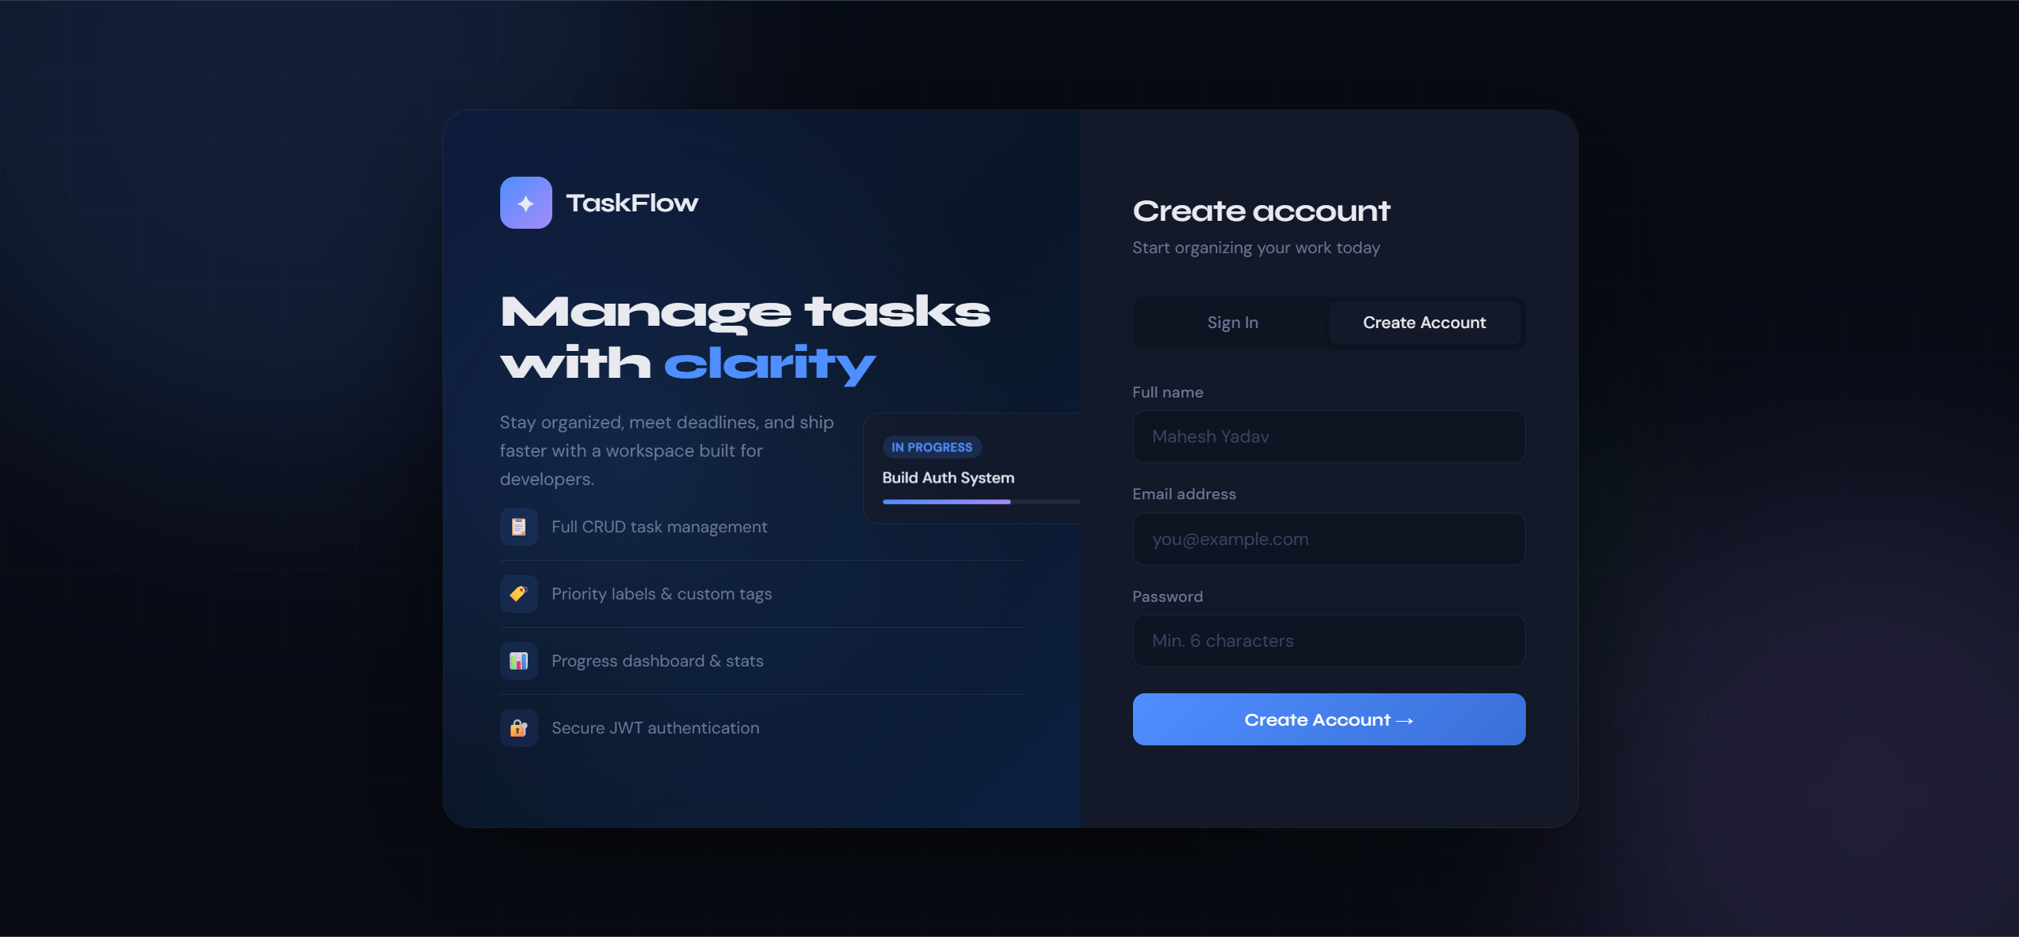

Module 2: Task Creation and Management
The task creation module provides a modal dialog accessible from the New Task button. The modal accepts task title, description, priority level (Low/Medium/High/Urgent), status, tag, and due date. On submission the task is created via POST /api/tasks/ and immediately appears in the Kanban board. Edit functionality opens the same modal pre-populated with existing data. Delete presents a confirmation dialog before calling DELETE /api/tasks/{id}.

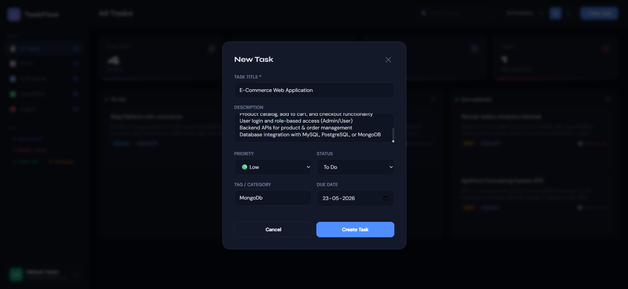
Module 3: Kanban Board with Drag and Drop
The Kanban board renders tasks in three columns: To Do, In Progress, and Completed. Task cards support HTML5 drag-and-drop — dragging a card and dropping onto another column triggers a PUT /api/tasks/{id} request updating the status. Each card displays title, description preview, priority badge, tag badge, and due date. Hover effects reveal Edit, Complete, and Delete action buttons.
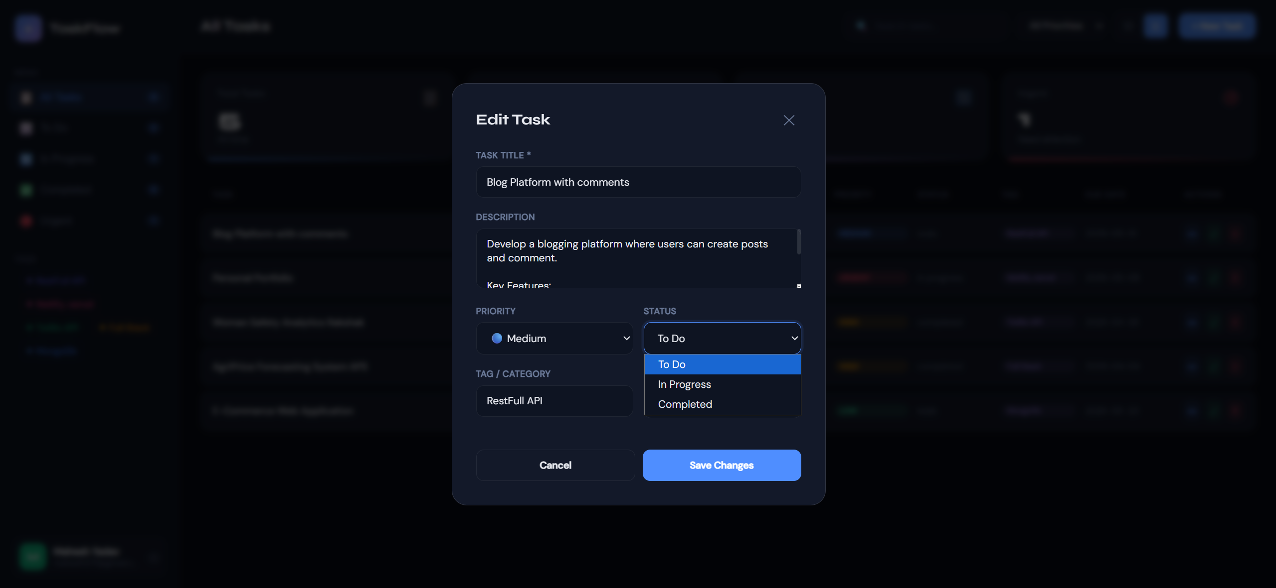
Module 4: List View
The list view provides a tabular representation of all tasks, toggled via the view button in the top bar. Tasks render in rows with columns for title, priority, status, tag, due date, and actions. Overdue tasks show a red due date. Completed tasks display with strikethrough styling. All action buttons perform the same API calls as the Kanban view.
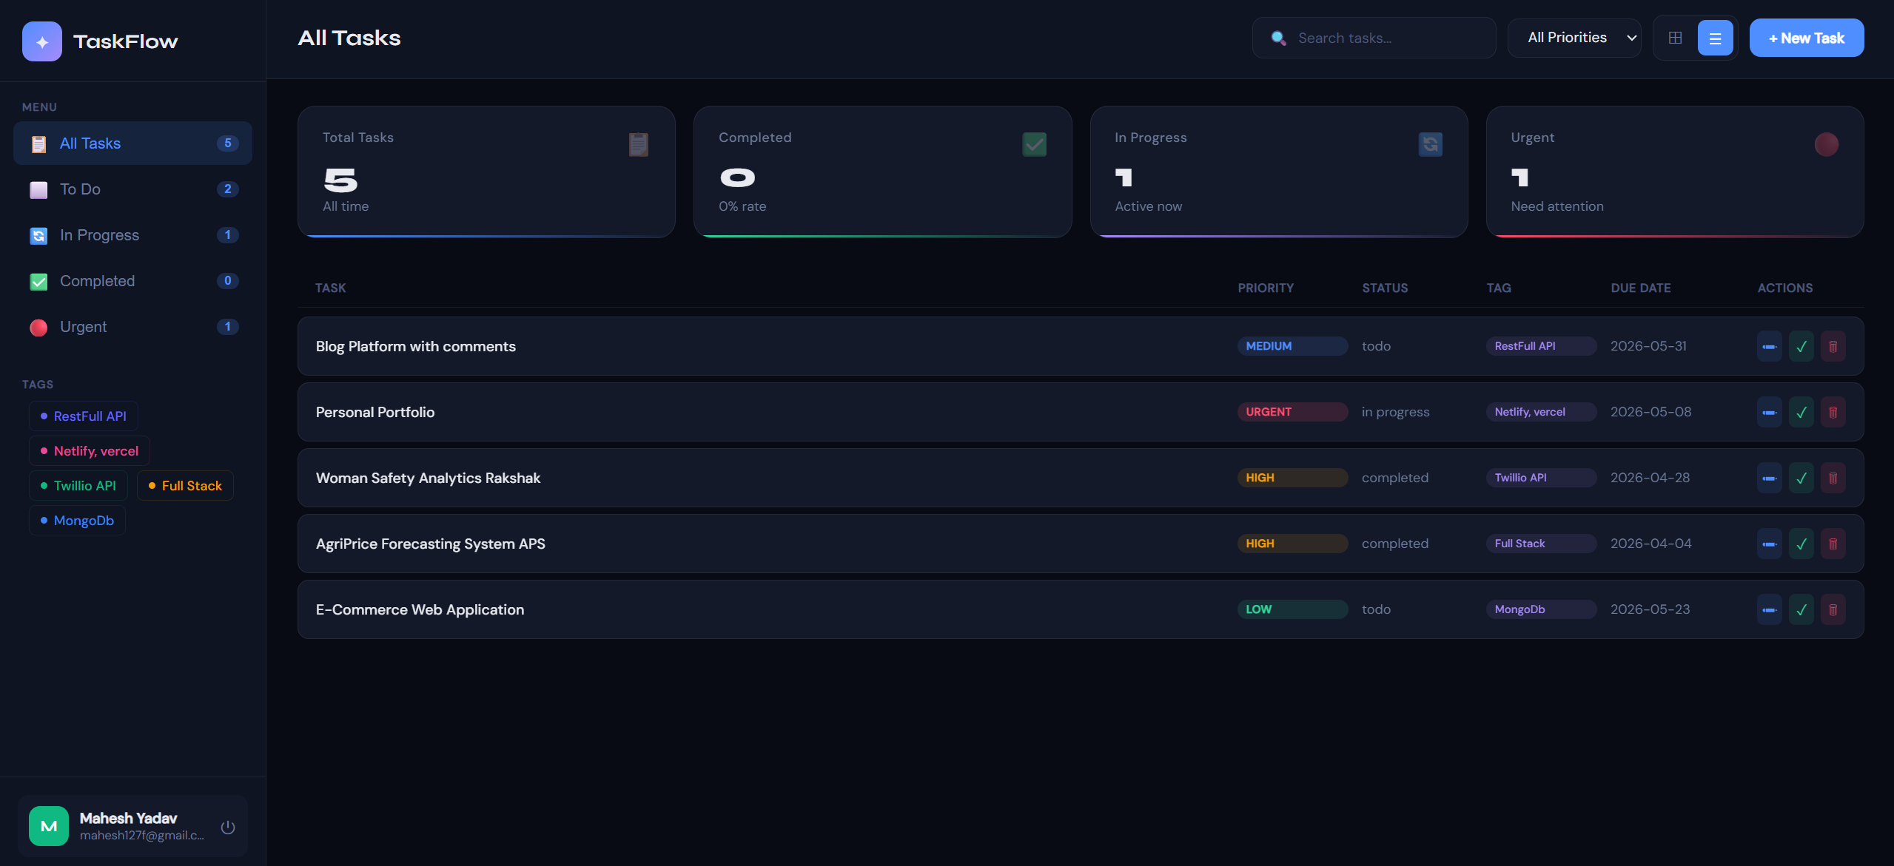
Module 5: Statistics Dashboard
Four metric cards display Total Tasks, Completed (with completion rate), In Progress, and Urgent counts. Statistics are computed from the full task list on every load and after every create, update, or delete operation. Each card has a coloured accent border and updates in real time as tasks change state.
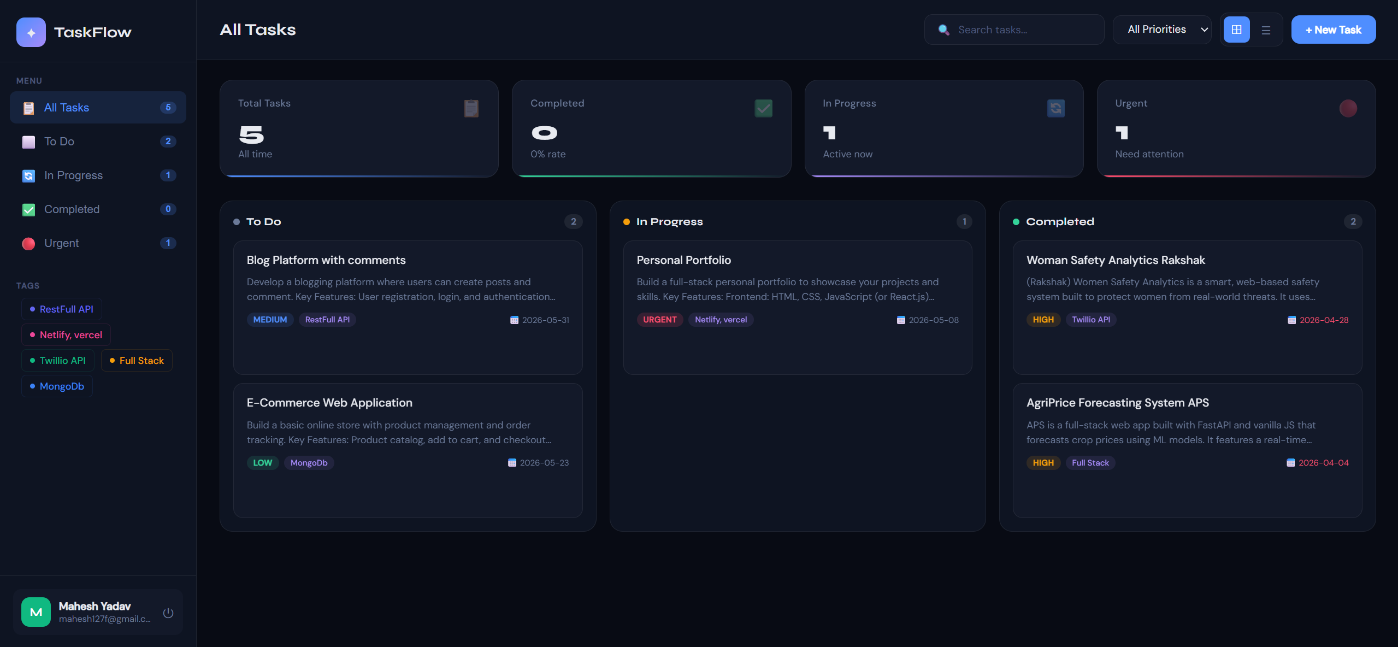
Module 6: Search, Filter, and Sidebar Navigation
The top bar provides live search filtering tasks by title and description. A priority filter dropdown filters to a single priority level. The sidebar navigation provides quick filters for All Tasks, To Do, In Progress, Completed, and Urgent with live count badges. Dynamically generated tag chips allow tag-based filtering. All filters compose simultaneously.

Testing and Results
Functional testing was conducted across all modules to verify correct behaviour under normal and edge-case conditions.

Test Case | Expected Result | Status
User registration with valid data | Account created, JWT token returned, redirect to dashboard | Pass
Login with correct credentials | JWT token returned, redirected to dashboard | Pass
Login with wrong password | 401 error shown, user stays on login page | Pass
Create task with all fields | Task appears in correct Kanban column immediately | Pass
Edit existing task | Modal opens pre-filled, changes saved on submit | Pass
Delete task with confirmation | Task removed from board after confirm dialog | Pass
Drag task to different column | Task status updated, card moves to new column | Pass
Search by task title | Only matching tasks displayed in real time | Pass
Filter by priority | Only tasks with selected priority shown | Pass
Toggle Kanban and List view | View switches without data reload | Pass
Stats update after task completion | Completion rate and counts update immediately | Pass
Vercel live deployment | Application loads and all features work via public URL | Pass

Conclusion
TaskFlow successfully delivers a complete, production-deployed full-stack task management application that meets all project objectives. The system demonstrates proficiency across the full web application development stack: RESTful API design with FastAPI, relational database modelling with SQLAlchemy, stateless JWT authentication, and professional frontend development with vanilla JavaScript.
The Kanban board with drag-and-drop, dual view modes, real-time statistics dashboard, multi-level filtering, and dark-themed responsive UI collectively deliver a user experience comparable to commercial task management tools. The application is live on Vercel and accessible to any user with a browser.
Future enhancements could include real-time WebSocket updates for collaborative task boards, sub-task support, file attachments, email notifications for due date reminders, and integration with a persistent cloud database for production-scale data storage.

References
- FastAPI Documentation - Tiangelo Palma Neto (2024). FastAPI Framework. https://fastapi.tiangolo.com
- SQLAlchemy Documentation - Mike Bayer (2024). SQLAlchemy ORM. https://docs.sqlalchemy.org
- Pydantic Documentation - Samuel Colvin (2024). Data Validation Library. https://docs.pydantic.dev
- Vercel Documentation - Vercel Inc. (2024). Serverless Deployment. https://vercel.com/docs
- MDN Web Docs - Mozilla Foundation (2024). HTML5 Drag and Drop API. https://developer.mozilla.org
- JSON Web Token Introduction - Auth0 Inc. (2024). JWT Standard. https://jwt.io/introduction
- Atlassian Agile Coach - Atlassian (2024). Kanban Methodology. https://www.atlassian.com/agile/kanban
- Python hashlib Documentation - Python Software Foundation (2024). https://docs.python.org/3/library/hashlib.html

